SmartCashier "Self-Checkout using RFID Technology"

Yousef F. Al-Ghamdi, Sultan S. Basaif, Omar M. Bawajeeh, Fazal Qudus Khan, Hassanin M. Al-Barhamtoshy
Faculty of Computing and Information Technology, King Abdulaziz University, Jeddah, Saudi Arabia
it.man@w.cn, ss_basaif@hotmail.com, q2-55@hotmail.com, fazalqudus@hotmail.com , hassanin@kau.edu.sa

ABSTRACT
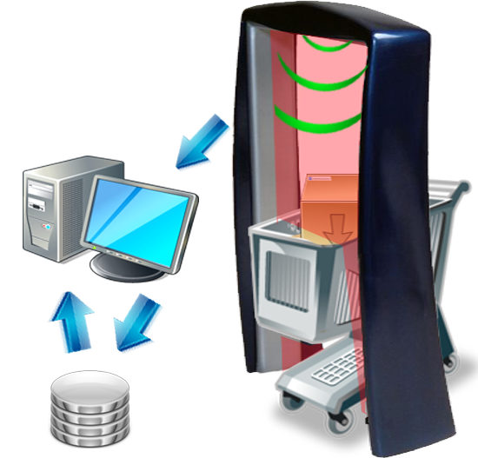
This paper provides an introduction to the multidisciplinary nature of Radio Frequency Identification (RFID) application as well as the complexity of radio frequency (RF) and data exchange for RFID-associated data. We propose the use of Self-Checkout using RFID Technology. Now with the noticed improvement in technology and communication, the world has become a small village where the people share information in an easy way. So, the time aspect is more important than ever and the people care about saving each and every second. Of course, everybody has been to markets in order to buy some items such as cloths, food, etc therefore the customer needs to find an empty cashier to complete the purchase process. The research is focus to fix this problem, here is the problem. There is a lot of time wasted duo to long queues, and effort on the Cashier consumption to deal with all the items one by one. All the existing solutions are using barcode technology to characterize by using a unique set of integer number for each product or items. This unique number is kept to restore the data of the products by passing the item’s barcode to a code reader. This step is rebated until the last item in the cart, and the system will calculate the total price. The research will implement RFID technology in order to replace the current system’s. will help to reduce the waiting time. With this system, customers fill their carts as usual, but instead of going to find an open cashier, they walk past an RFID reader gates on their way out the door. The reader reads all of items in the cart in a matter of seconds, and the customer pay the total amount to the cashier worker and gets the receipt and resource saving.

The proposed solution is designed and implemented by using UHF-RW-MP-232-V1 RFID reader. Therefore, the proposed system for the Smart Cashier includes tagged objects (Items), read object (RFID-Reader) and the computing system is implemented using Java platform. Different resources are needed such as RFID-kit (Reader and Tags) as well as associated items like ID-tags that will contain information about products. The reader will be embedded and installed at the gate. The installed hardware with the related software and database is used to handle this situation when the cart move through the gate. The reader sends UHF “Ultra High Frequency” radio waves to the tag (Passive-Tag). When the tag receives this signal it will convert it to energy to resend back the signal that will contains information about items. The reader will receive the signal from tag and will process the information by the program then will display the result on a monitor. All these Operations will be done in a matter of seconds.

